**Date**: 02/15/2025

**Student**: Nino Ghonghadze

**ART157**: **Introduction to Art**

Describing Art

In The Penitent Magdalene, the artist uses light and shadow to create a strong feeling of emotion. The woman’s face and hands are bright, while the background is dark, making her the main focus. Her sad eyes and tilted head show that she is deep in thought, feeling regret or sorrow. The way she rests her head on her hand makes her look tired and lost in reflection.

She holds a skull in her hands, which is a powerful symbol of death and the shortness of life. This detail might remind us that life does not last forever and makes her sadness feel even deeper. Her hair is loose and a little messy, which adds to the idea that she is going through a difficult time. The soft texture of her skin and hair contrasts with the rough look of the skull, making the painting feel more real.

The dark background makes her stand out even more, while the folds of her red robe add movement and richness to the painting. The way her arm curves toward her face naturally leads our eyes to her expression, making us feel connected to her emotions.

Overall, the painting is about deep feelings, regret, and thinking about life. The artist’s use of light, color, and texture helps tell this story in a way that feels very real and powerful.

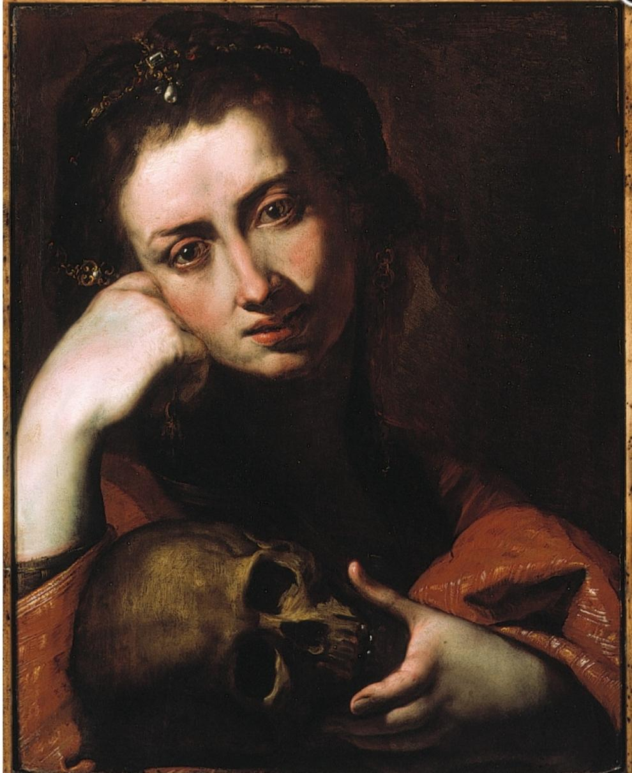

**The Penitent Magdalene**

Previously attributed to Jusepe de Ribera (AKA Lo Spagnoletto) Secondary Artist

Giulio Cesare Procaccini

Previously attributed to Angelo Caroselli Secondary Artist

Oil on panel

17th century Italy Painting Oil Painting